Interactive Graphical User Interface for 3D Transformation of Geometrical Shapes

# Transformation Matrices:-

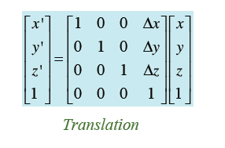 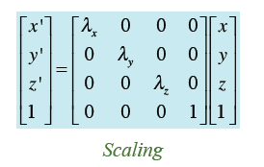

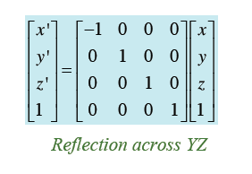

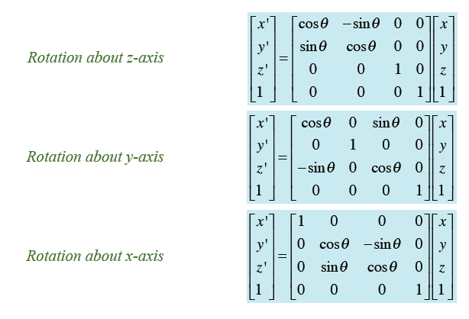

*Rotation about an Arbitrary Axis* [M]= [T] [Rx] [Ry] [Rtheta] [Ry]-1 [Rx]-1 [T]-1

*Reflection across an Arbitrary Plane* [M]= [T] [Rx] [Ry] [Reflz] [Ry]-1 [Rx]-1 [T]-1

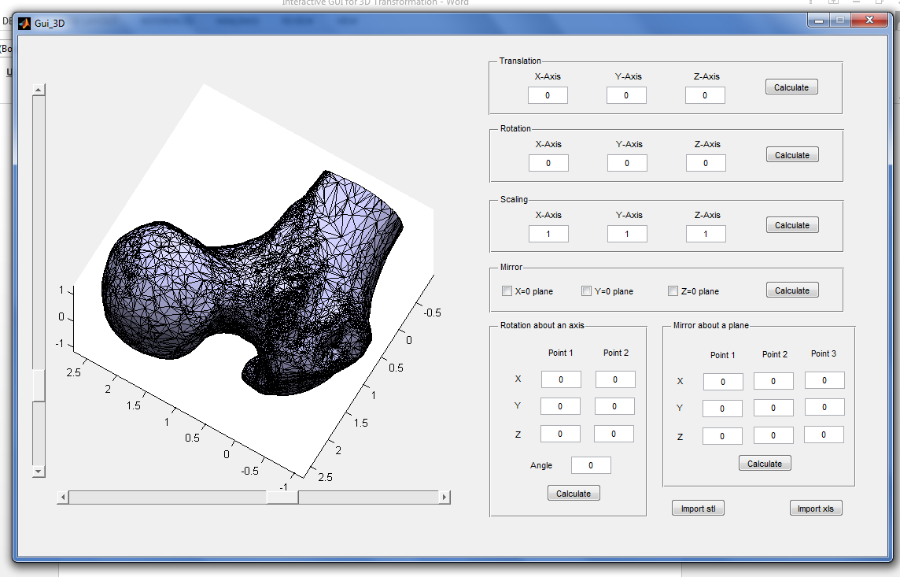

Example of an input from stl file of Human Bone

## Input form:-

solid vcg

facet normal -2.320966e-003 -9.999969e-001 -8.762344e-004

outer loop

vertex -2.468989e-001 -9.935274e-001 3.039794e-001

vertex -2.583674e-001 -9.935263e-001 3.332009e-001

vertex -2.468989e-001 -9.935204e-001 2.960206e-001

endloop

endfacet

facet normal -2.323857e-003 -9.999969e-001 -8.773699e-004

…

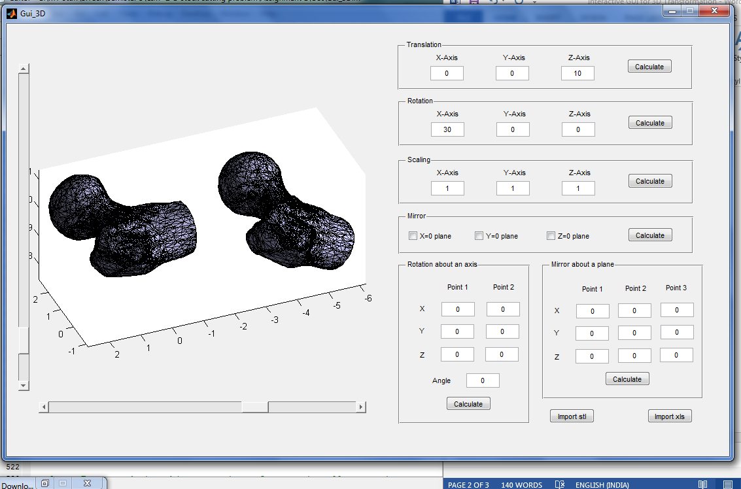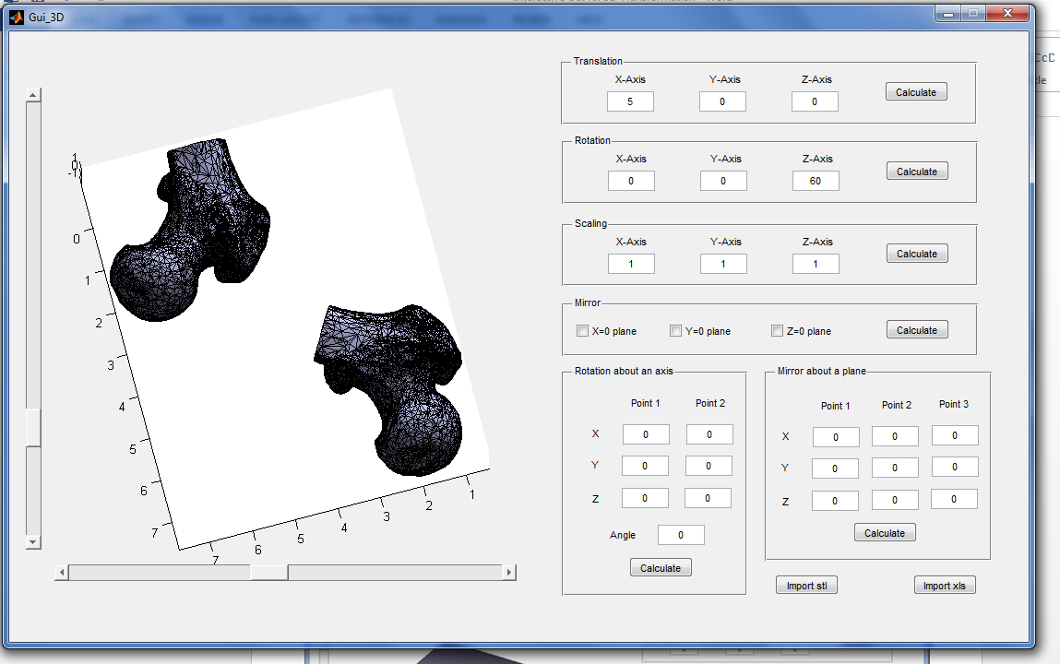

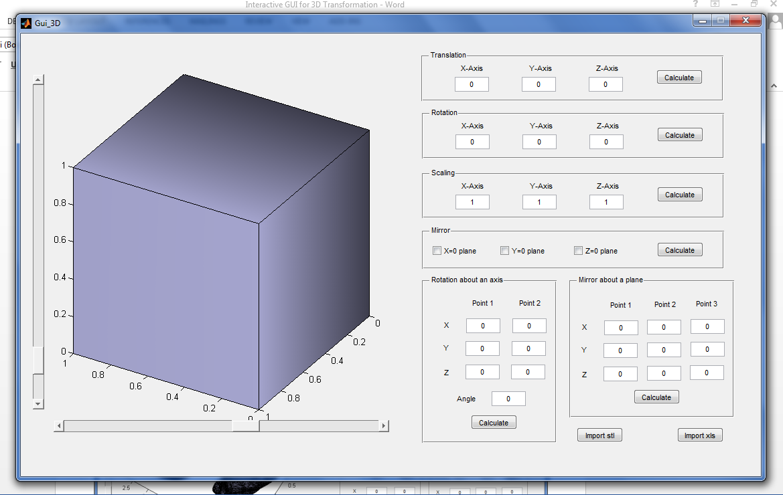

Example of an input from xls file of a Simple Cube

## Input form:-

Points Faces

|  |  |  |
| --- | --- | --- |
| 0 | 0 | 0 |
| 1 | 0 | 0 |
| 1 | 1 | 0 |
| 0 | 1 | 0 |
| 0 | 0 | 1 |
| 1 | 0 | 1 |
| 1 | 1 | 1 |
| 0 | 1 | 1 |

|  |  |  |  |
| --- | --- | --- | --- |
| 1 | 2 | 3 | 4 |
| 5 | 6 | 7 | 8 |
| 1 | 2 | 6 | 5 |
| 3 | 4 | 8 | 7 |
| 1 | 4 | 8 | 5 |
| 2 | 3 | 7 | 6 |

